Mehran University of Engineering and Technology Shaheed Zulfiquar Ali Bhutto Campus, Khairpur Mir’s Department of Software Engineering

**Course: Software Design & Architecture SW-227 (Practical) - Instructor: Engr. Shamshad Naveed**

# Lab No. 13

**Objective: Procedural Design (Pseudo Code)**

|  |  |  |  |  |
| --- | --- | --- | --- | --- |
| **Name:** | **Mohammad Ibraheem** | **Roll Number:** | | **K20-19SW31** |
| **Score:** | **Signature:** | **Date:** | **25-09-2022** | |

|  |  |  |  |  |  |  |  |
| --- | --- | --- | --- | --- | --- | --- | --- |
| **LAB PERFORMANCE INDICATOR** | SUBJECT KNOWLEDGE | DATA ANALYSIS AND INTERPRETATION | ABILITY TO CONDUCT EXPERIMENT | PRESENTATION | CALCULATION AND CODING | OBSERVATION  /RESULTS | SCORE |
|  |  |  |  |  |  |  |  |

**Task :** Pseudo Code

# Code:

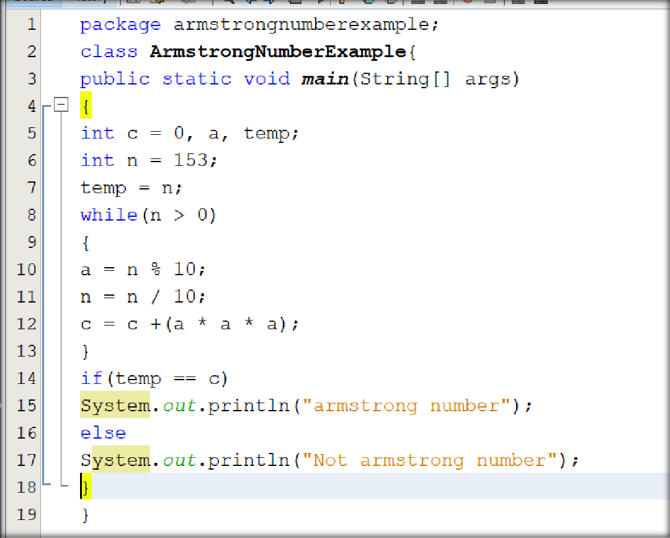

**Pseudo Code of above code**

The pseudocode of the above program can be written in the following way:

* Initialize c to zero
* Initialize n to a random number to check Armstrong
* Initialize temp to n.
* Repeat steps until the value of n are greater than zero.
* Find a reminder of n by using n%10.
* Remove the last digit from the number by using n/10.
* Find the thrice of the reminder and add it to c.
* If temp == c
* Print "Armstrong number"
* else
* Not an Armstrong number"